**IMAGE CAPTION GENERATOR USING SENTIMENT ANALYSIS**

**AIM OF THE PROJECT:**

To automatically generate caption for images and customize them according to various factors such as background, age, perception and also use sentiment analysis.

**DESCRIPTION:**

In this project, we intend to develop an app which can access pictures and generate captions for them according to the sentiment analysed. We feed a set of captions with images, so that when user inputs the image, the app automatically will generate the caption for the same.

**TECHNOLOGY STACK:**

1. Android App Development for the user interface

Flutter/Kotlin

1. Machine learning:
2. Data acquisition
3. Using the collected and pre processed data(images in this context) to train the model so that fulfills our aim accordingly
4. Analysis according to user input(analyse features such as expression and background)
5. Generate an appropriate caption for the image
6. DBMS

**BLOCK DIAGRAM**

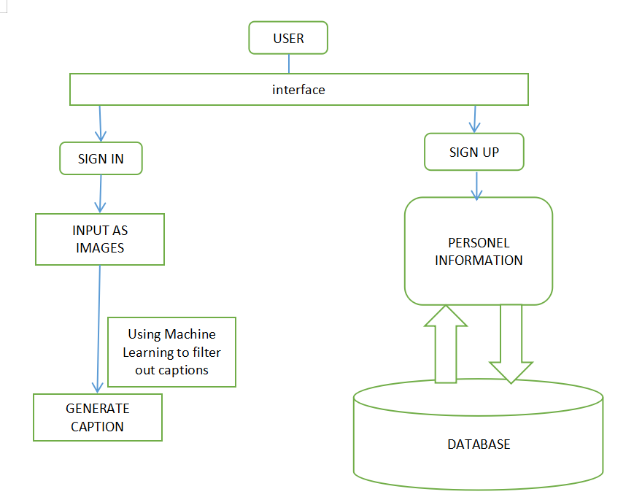

**GROUP MEMBERS:**

Drishti Kishore(1805341)

Tanisha Banik(1805354)

Rakhi Sinha(1805321)

Kalpana Sinha(1805299)

Sayantani Das(1805338)

Gaurav Kumar(1805298)

Ayush Pandey(1805290)

Abhishek Mandal(1805273)

Vaibhav(1805176)

Vinayak(1805180)